**10 SCIENCE 2014**

### CHEMISTRY TEST ONE

Name: ____________________ Teacher: ___________________ Mark: /55

**Percentage: %**

**SECTION A: MULTIPLE CHOICE (10 marks)**

**Please answer on the separate multiple choice answer grid below.**

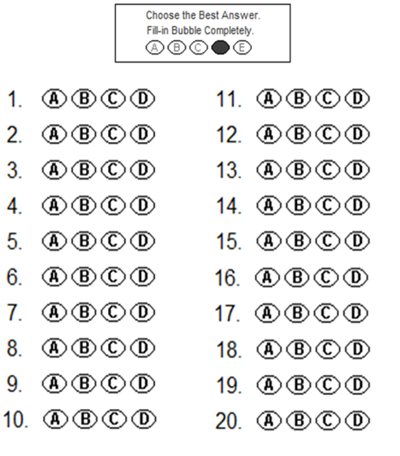



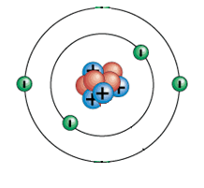**1.** The atom on the right has a:

(a) Neutral charge.

(b) Positive charge.

(c) Negative charge.

(d) Nucleus charge.

**2.** The periodic table was first put together in 1869 by the Russian chemist:

(a) Ernest Rutherford.

(b) John Newlands.

(c) Dmitri Mendeleev.

(d) Antoine Lavoisier.

**3.** Choose the correct definition for ‘atom’.

(a) The smallest part of an element that can take place in a chemical reaction.

(b) The smallest part of a cell.

(c) Anything that takes up space and has mass.

(d) The smallest part of an element that is unable to take place in a chemical reaction.

**4.** A substance made up of atoms with the same atomic number is known as:

(a) an element.

(b) an atom.

(c) a proton.

(d) a particle.

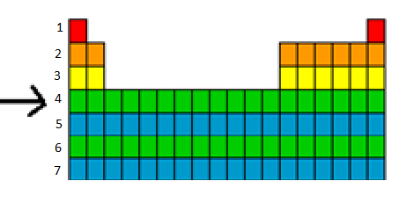**5.** The arrow is pointing to a:

(a) column.

(b) period.

(c) row.

(d) group.

**6.** Gold is written as on the periodic table. From this we know that:



(a) it contains 118 protons.

(b) it contains a total of 197 protons, neutrons and electrons.

(c) it contains 118 neutrons.

(d) it contains 197 electrons.

**7.** The noble gases are all:

(a) found on the right hand side of the periodic table and highly reactive.

(b) found on the left hand side of the periodic table and highly reactive.

(c) found on the right hand of the periodic table and unreactive.

(d) found on the left hand of the periodic table and unreactive.

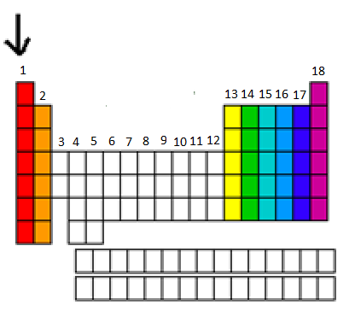**8.** The arrow is pointing to a:

(a) column.

(b) period.

(c) group.

(d) bar.

**9.** Which of the following are all transition metals?

(a) Li, Mn, Ca.

(b) Mn, Fe, Cu.

(c) F, Cl, Br.

(d) Na, K, Fe.

**10.** A particular atom has 8 protons, 8 electrons and 9 neutrons. Its atomic number is:

(a) 8.

(b) 9.

(c) 17.

(d) 1.

**SECTION B: SHORT ANSWER (45 marks)**

**1.** Fill in the table below. (10 marks)

|  |  |
| --- | --- |
| **Element** | **Symbol** |
| Helium |  |
|  | Be |
| Carbon |  |
|  | P |
|  | K |
| Calcium |  |
|  | Li |
|  | B |
| Silicon |  |
|  | S |
|  | Cl |
| Oxygen |  |
|  | H |
| Nitrogen |  |
|  | F |
| Neon |  |
| Aluminium |  |
|  | Ar |
| Sodium |  |
|  | Mg |

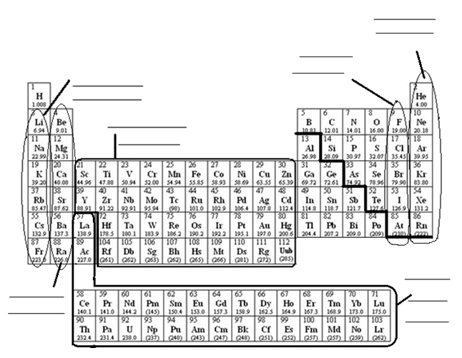**2a.** Fill in the diagram of the periodic table below. (6 marks)

**b.** Fill in the table below using the periodic table above. (4 marks)

|  |  |
| --- | --- |
| Element | Group of the periodic table |
| Lithium |  |
| Helium |  |
| Chlorine |  |
| Iron |  |

**3.** State the number of electrons that fill the shells in an atom. (1.5 marks)

First shell: ______________

Second shell: ______________

Third shell: ______________

**4.** Label the diagram of the atom below. (2.5 marks)

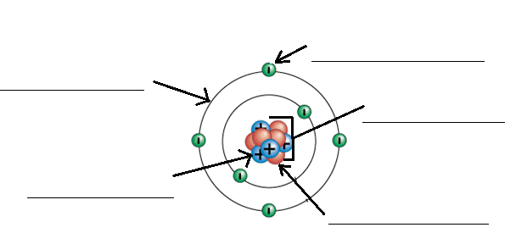

**5.** Complete the electron configurations below (neatly in pencil). (6 marks)

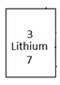

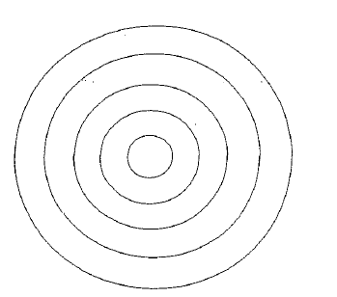

**6.** Fill in the table below using the periodic table included at the end of the test. (10 marks)

|  |  |  |  |  |  |
| --- | --- | --- | --- | --- | --- |
| Element | Atomic number | Mass number | Number of protons in each atom of the element | Number of neutrons in each atom of the element | Number of electrons in atom of the element. |
| Silver |  |  |  |  |  |
| Helium |  |  |  |  |  |
| Magnesium |  |  |  |  |  |
| Sodium |  |  |  |  |  |

**7.** Draw a graph using the information from the table below. (5 marks)

Don’t forget all the things that a graph needs!

|  |  |
| --- | --- |
| **Year** | **Number of elements known** |
| 1789 | 31 |
| 1808 | 36 |
| 1829 | 55 |
| 1864 | 60 |
| 2001 | 118 |

[](http://www.google.com.au/url?sa=i&rct=j&q=graph+paper&source=images&cd=&cad=rja&uact=8&docid=bnDyK-WDEHhooM&tbnid=OH_xw5ZTcFEuvM:&ved=0CAUQjRw&url=http://virtualmathtutor.blogspot.com/2010/11/how-to-draw-circle-without-compass.html&ei=RKw4U5fxF8fClQWCrIGoCQ&psig=AFQjCNHahbsWAgdANQM5RZCXw4z48cLLBw&ust=1396309252654415)

